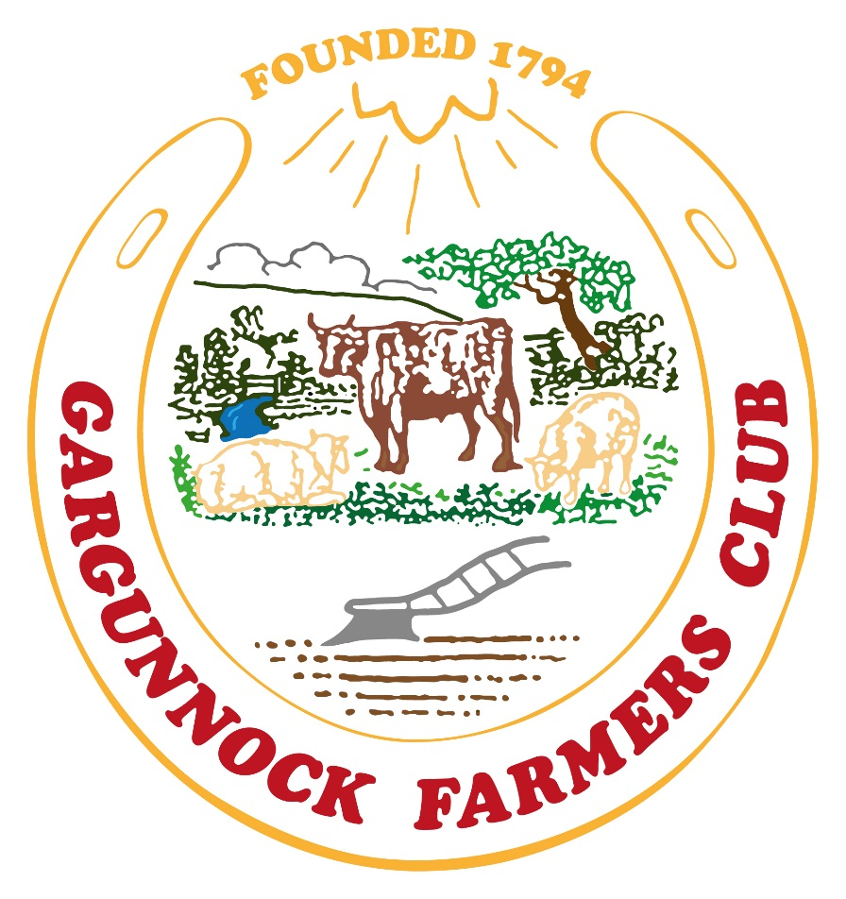

GARGUNNOCK SHOW

1st June 2019

SCHEDULE OF CLASSES FOR

BAKING, PRODUCE, FLORAL ART, HANDCRAFTS, PHOTOGRAPHY AND CHILDREN’S PAINTING

BAKING AND FLORAL ART

Entries to be in place by 9.30am
Judging to commence at 10.00am
Names and ages (for children’s section) to be attached on folded paper or card to each exhibit

BAKING SECTION

ADULTS BAKING AND PRODUCE

Judge: Ann Ronald, Drymen
Head Stewards: Ladies of Gargunnock WRI

Class 1 Four Pancakes.
Class 2 Four Treacle Scones
Class 3 Four Belgian buns
Class 4 Four Empire biscuits
Class 5 Four Macaroon bars
Class 6 Sultana cake
Class 7 Apple pie
Class 8 One Jar Home Made Lemon Curd
Class 9 One Jar Home Made Strawberry jam
Class 10 Six Fresh White Hen Eggs
Class 11 Six Fresh Brown Hen Eggs
Class 12 Six Fresh Duck Eggs
(all eggs must be from poultry kept on the owner’s property and must not be bought).

Silver Medal for BEST EXHIBIT IN BAKING AND PRODUCE SECTION

Perpetual Silver Cup presented by Mrs. E. M. Stirling and other ladies of the family for the Winner of the Points Prize in Baking and Produce Section
1st – 3 points, 2nd – 2 points, 3rd – 1 point.

In the spirit of “The Great British Bakeoff” we are having a special class
“The Showstopper”
This year’s theme is
225th Anniversary

Maximum 3 tiers
Cake to be judged on decoration only
Class open to all ages (Not eligible to compete for Best Exhibit)

CHILDREN’S BAKING

Judge: Heather Millar, Thornhill

Children up to 6 years

Class 13 Four Crispie Cakes
Class 14 Decorated Digestive Biscuit farm animal (decoration only to be judged)

Children 7-12 years

Class 15 Four Pancakes
Class 16 Four Plain Scones
Class 17 Four Slices of Uncooked Traybake
Class 18 Four Decorated cupcakes (decoration only to be judged)

Children 13-17 years

Class 19 Four Fruit Scones
Class 20 Four Pancakes
Class 21 Quiche
Class 22 Four decorated cupcakes (decoration only to be judged)

Child up to Six Years Old –Trophy for Baking & Floral Art Sponsored by Maitland Clark
(All Children’s exhibits must be their own unaided work)
1st – 3 points, 2nd – 2 points, 3rd – 1 point

The Mitchell Cup to child, 7 years to 12 years with most points in Baking Section and Floral Art (All Children’s exhibits must be their own unaided work)
1st – 3 points, 2nd – 2 points, 3rd – 1 point

The Kyle Cup for child 13 years to 17 years with the most points in Baking Section and Floral Art (All children’s exhibits must be their own work)
1st – 3 points, 2nd – 2 points, 3rd – 1 point

FLORAL ART

Judge: Fiona Hamilton, Buchlyvie

Adults:

Class 23 Arrangement with a Candle Centre
Class 24 Arrangement using a Kitchen utensil
Class 25 Arrangement depicting “Scottish Summer”
Class 26 Arrangement using foliage only
Class 27 Wedding bouquet

A.R. Williams Cup for Best Exhibit in Floral Art Section
Special Rosette for Best Exhibit in Floral Art Section

Silver Medal for BEST EXHIBIT IN FLORAL ART SECTION

The Major Connal-Rowan Trophy for the Winner of Points Prize for Floral Art Section
1st – 3 points, 2nd – 2 points, 3rd – 1 point

Children – up to 6 years

Class 28 Pressed Flower
Class 29 Arrangement in a Welly boot

Children 7-12 years

Class 30 Flower rosette
Class 31 Arrangement in a Teapot

Children 13-17

Class 32 Arrangement depicting “show day”
Class 33 Arrangement in a Mug

Special Rosette for Best Exhibit in Children’s Section

HANDCRAFTS SECTION

Judge: Sheena Ogg, Gargunnock

Adults:

Class 34 Hand made rosette
Class 35 Handmade Scented Soap
Class 36 Decorated Ceramic Plant Pot
Class 37 Farm sign (any craft)

Special Rosette for Best Exhibit in Adult’s Handcrafts

Children:

Class 38 Thank you card
Class 39 Decorated Money box
Class 40 Finger puppet
Class 41 Pompom animal

Special Rosette for Best Exhibit in Children’s Handcrafts

PHOTOGRAPHIC COMPETITION

Judge: Willie Muirhead, Gargunnock

Adults:

Class 42 Landscape (waterfall)
Class 43 Portait- Person or Animal
Class 44 Funny Photo Caption

Children:
Class 45 Tractor
Class 46 Flower
Class 47 My Favourite Thing

All photographs must be unframed and no bigger than 6” x 4”. All entries in this competition must be handed in by 9.30am and must have the entrant’s name written on the reverse of the photograph and the number of the class in which it is to be exhibited. Exhibitors can reclaim their photographs after 3.30pm. We would be most grateful if we could use some photos, with your permission, for the website.

CHILDRENS PAINTING

Judge: Elma Reilly, Kippen

The classes in this section will be divided into:

Nursery/Pre-School Open Theme
Primary 1, Primary 2, Primary 3: Farm animal
Primary 4, Primary 5: Tractor
Primary 6, Primary 7 Show day

Name, age and school to be written on back

